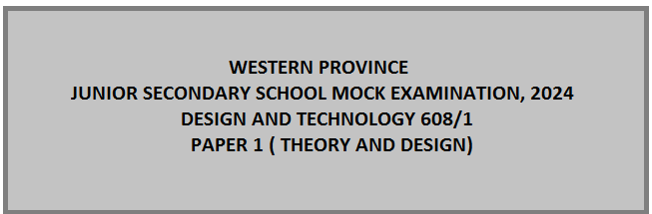

Time: 2 hours 30 minutes marks: 155
Instructions to Candidates
    - Write your answers on a separate sheet(s) of paper.
    - Write your name and examination numbers on your answer sheets
    - There are three(3) sections in this paper (Section A, B and C)
    - Section A has thirty (30) questions, answer all by writing the correct answer of your choice
Section B has one question, answer it all.
    - Section C has 3 parts
Part I has a compulsory question
Part II has two questions, you are required to answer one
Part III has two questions. You are required to answer one

SECTION A ( 30 marks)
Answer all the questions in this section by circling or marking an ‘X” against correct answer of your choice
- The material that is synthetic or semi-synthetic organic polymer is ……………
- Metal
- Wood
- Grass
- Plastic
- plastics classified into………………. types
- 2
- 3
- 4
- 5

- Plastics that can undergo chemical change in their composition when heated and they can be re-heated and molded many times are called ………………………
- Thermoplastics
- Thermosets
- Plastic memory
- Bending
- Plastics are commonly used as ……………………………..
- Insulators
- Electrical cables
- Cooking utensils
- Coating materials
- …………………………. Is the ability by which some plastic can return to their original form when hot.
- Vacuum forming
- Bending
- Press forming
- Plastic memory
- Which of the following is not a ferrous metal?
- Copper
- Cast iron
- Carbon steel
- Stainless steel
- Metals are classified into………………. Classes
  - 5
  - 4
  - 3
  - 2

- What is a ferrous metal?
- These are metals and alloys that do not contain iron.
- These are metals that have high resistance to rust and corrosion
- These are metals and alloys that contain iron.
- These are soft metals like potassium.
- An alloy is a metal that is made from……………………………………..
- two or more metals.
- One metal
- 100% iron
- Precious minerals.
- An alloy made of tin and copper is ………………………
- Brass
- Bronze
- Steel
- Solder
- Wood is classified into………………. types
  - 2
  - 3
  - 4
  - 5
- Safety is emphasized in the D & T workshop so that …..
- Tools are not stolen
- Teachers can be distinguished from pupils
- A lot of tools can be kept in the store room
- Individuals are protected from injury and death

- What does the term “seasoning” mean?

- Removing excess moisture from timber
- Preserving timber for further use
- Testing the amount of moisture in timber
- Sawing timber into marketable sizes

- Which of the following is a ferrous metal?

- Copper B. Steel C. Brass D. Aluminium

- Which of the following timbers is classified as softwood?

- Meranti C. South African Pine
- Mukwa D. Jelutong

- Which of the following figures is a prism?

A B C D
- Which line from the diagram below is a tangent?
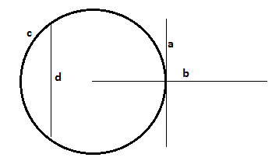
- Line a
- Line b
- Line c
- Line d

- The line below is called:

- Centre line
- Hidden detail
- Projection line
- Break – solid line
- Line that runs from the Centre of a circle and meets the tangent on the circumference at 90°is called …………………………..
- Chord
- Radius
- Normal
- Diameter
- Metals that can be drawn into wire are said to be ………………………….
- Brittle
- Ductile
- Malleable
- Tough
- Which of the following represents a welded joint?
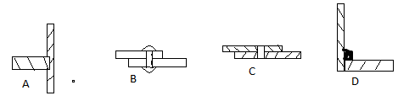
- John, a grade 9 learner, wore a shield when welding some pieces of metal. Why did he do that?
- He did not have goggles
- To look professional while working
- To protect his eyes from welding arcs
- To show that he is able to see clearly
- Sharon has made an artefact for her major project. Most the materials she has used are metal. Identify the method of joining that will not be suitable for her to use.
- Dovetail
- Riveting
- Soldering
- Welding
- Figure 7 shows a shaped block
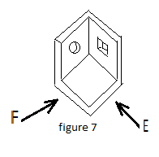
Select the view that represent the correct front elevation.
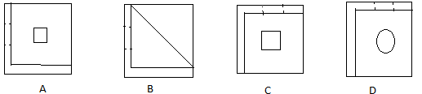
- Figure 8 shows a tin being opened. Identify the load.
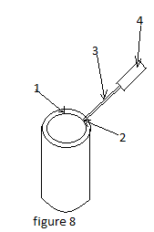
- 4
- 3
- 2
- 1
- A cut that has been made by a saw is called …………………………..
- Cuttings
- Deep cut
- Kerf
- Scratch
- Figure 9 shows a method of constructing a polygon to be constructed.
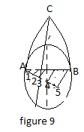
- Hexagon
- Nonagon
- Octagon
- Pentagon
- What term is used to describe the process of applying shade or colour to increase the sense of three dimensions?
- Pattern
- Polishing
- Rendering
- Textile
- ………… is used for restricting the flow of electricity in an electric circuit.
- Capacitor
- Diode
- Resistor
- Switch
- The following are characteristics of an entrepreneur except ……………………….
- Avoiding risks
- Creativity
- Persistent
- Self-confident

SECTION B (30 marks)
- (a) Write four careers that a learner doing Design and Technology can pursue as an entrepreneur. (4)
(b) Figure 10 shows one of the joints used in to make furniture (chairs or tables)
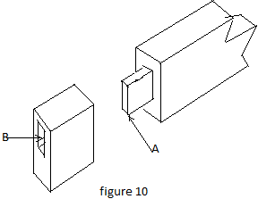
  - Name the joint (1)
  - List down two main members of the joint. (2)
  - List three tools you would use for making part A (3)
  - Write three tools you would use when cutting Parts A and B (3)
( c) Give two examples of finishes used on wood.
(d) figure 11 shows electronic components linked together to form a circuit
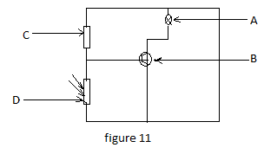
- Which part act as a fast switch? (1)
- Identify the part that reduces the sizes of the current in the circuit. (1)
(e) The diagram in figure 12 below shows one of the tools used in Design and Technology work room
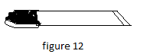
    - Name the tool (1)
    - To which class of tools does it belong? (1)
    - What is the use of the tool? (2)
(f) List two types of angles (2)
(g) Mention two methods of wasting wood. (2)
(h) Figures 13 shows a gear train. Study it and answer the questions below.
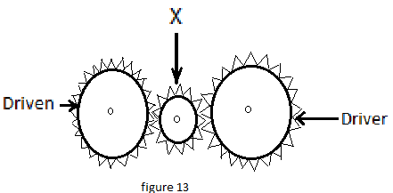
- Identify gear X (1)
- In which direction will the driven gear rotate? (1)
- State one machine that uses gears (1)
- i. Give one role material of mortar (1)
ii. State one example of fine aggregate (1)
- Structures are objects that provide support to a load.
- Give one other function of a structure (1)
- Write any one group of structures? (1)

SECTION C (95 marks)
Answer two questions from this section. Question 32 is compulsory. Choose the other one from the rest.
Part 1 - compulsory
- Figure 14 shows an office stationary tray for keeping pens, rulers, rubbers, paint brushes and pencils.
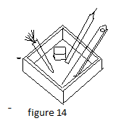
- (i) Name any two suitable materials for the stationary tray ( 2mrk)
(ii} Give two reasons for your choice ( 4 mrk)
- (i) Identify the problem from figure 14 (2 mrk)
(ii). Suggest a design brief from the problem in (b) (i) (3 mrks)
(iii). Write four specifications that can be considered when coming up with the possible solutions. ( 4 mrks)
( c) Sketch, freehand, a pictorial drawing showing how you would improve the tray. You may
Consider the following: interpretation, proportion, safety, shape, rendering etc. (15 mrks)
TOTAL: 30 marks
Part II
ELTHER
- A (a) (i) Sketch, in good proportion, a drawing of a flat cold chisel. ( 6 mrks)
(ii). Label two parts. ( 2 mrks)
(iii). State two uses of a flat cold chisel. ( 4 mrks)
(iv) Why is the head of the cold chisel left soft. Give two reasons. ( 4 mrks)
(b). Figure 15 shows a row design of a desk to be used for teaching and learning
Graphic communication.
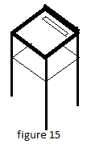
(i) Give one advantage of using the desk ( 2 mrk)
(ii). List six specifications that can be considered in design of the desk ( 6 mrks)
(iii). Write, in a sequence, six stages in design process from situation. ( 6 mrks)
TOTAL: 30 marks

OR
B(a) (i) List four Characteristics of a successful entrepreneur. ( 4 mrks)
(ii). Write two business activities taking place in your community. ( 4 mrks)
(iii). Define a business plan. ( 3 mrks)
(iv). Mention four main parts of a business plan ( 4 mrks)
(b). State four factors that can hinder the growth of a business. ( 4 mrks)
( c). Dalitso was sent to buy the following items
- 2kg nails costing K12.50 per kg
- 1 litre tin of varnish costing K12.50 per litre
- 2 tins of 1 litre paint costing K25.00 each
- 1 hacksaw costing K37.50 eacn.
(i). How much did he spend on the items listed above? (6 mrks)
(ii). If the Supermarket charge 16% VAT from the total amount you found in (i), Calculate the value of VAT. (5 mrks)
TOTAL: 30 marks
Part III
- Elther (A). In your community, people think that the outbreak of cholera is not real but
rather political pronouncement.
    - You are asked to design a poster on which you will communicate by printing “CHOLERA IS REAL. The poster should be octagonal in shape whose distance across its flats is 100mm. You can use any type of lettering style with a font size that should fit and give you a balanced spacing. (23 marks)
    - The drawing in the figure below shows an isometric projection of the letter “L” from the word Real. The letter “L” from the word Real has been extracted and drawn separate using the isometric grid,
Draw the letter L if the height is 100mm and the width is 45mm.
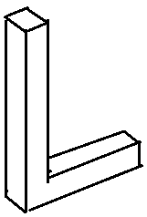
(12 marks)
TOTAL [35 Marks]
OR
(B) (I.) The figure below shows the sketch of land scape for a shopping mall.
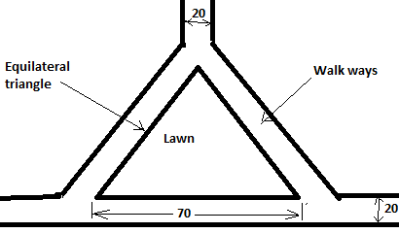
(a) Draw the figure showing all geometrical contractions. (12)
(b) Improve the sharp corners of the Triangular lawn which makes it difficult
for cars to turn. (6)
(c) Improve the walk ways by showing any kind of decorations. (5)
(II.) The drawing in the figure below shows an isometric projection of the
letter “L” from the word Real. The letter “L” from the word Real has
been extracted and drawn separate using the isometric grid,
Draw the letter L if the height is 100mm and the width is 45mm.
(12 marks)
TOTAL [35 Marks

